

INTERNATIONAL SCHOOL OF MANAGEMENT & TECHNOLOGY

**ASSIGNMENT COVER SHEET**

|  |  |  |  |
| --- | --- | --- | --- |
| STUDENT DETAILS | | | |
|  | | | |
| Student ID |  | **Reg No.** |  |
| Family Name | Shrestha | **Given Name** | Bisesh |
| Enrolment Year | 2019 | **Section** | N4 |
| Semester | 3RD | **Email** | bisesh@ismt.edu.np |

|  |  |  |  |  |
| --- | --- | --- | --- | --- |
| UNIT DETAILS | | | | |
| Unit Title | Business Intelligence | **Unit Code** | M/615/1641 | |
| Assessor Name | **Sailesh Subedi** | **Issued Date** | 06/03/2021 | |
| Assignment Title | **Business Intelligence** | | | |
| Assignment No | **1/1** | **Submission Date** | | 08/02/2021 |
| Qualification | BTEC HND IN COMPUTING | **Campus** | | **ISMT** |





**STUDENT ASSESSMENT SUBMISSION AND DECLARATION**

When submitting evidence for assessment, each student must sign a declaration confirming that the work is their own.

|  |  |  |  |
| --- | --- | --- | --- |
| Student Name | Bisesh Shrestha | Assessor Name | Sailesh Subedi |
| Issue Date | 06/03/2021 | Submission Date | 08/02/2021 |
| Programme | Networking | | |
| Unit Name | Business Intelligence | | |
| Assignment Title | Business intelligence | | |

**Plagiarism**

Plagiarism is a particular form of cheating. Plagiarism must be avoided at all costs and students who break the rules, however innocently, may be penalized. It is your responsibility to ensure that you understand correct referencing practices. As a university level student, you are expected to use appropriate references throughout and keep carefully detailed notes of all your sources of materials for material you have used in your work, including any material downloaded from the Internet. Please consult the relevant unit lecturer or your course tutor if you need any further advice.

**Student Declaration**

I certify that the assignment submission is entirely my own work and I fully understand the consequences of plagiarism. I understand that making a false declaration is a form of malpractice.



Pearson Education 2018  
Higher Education Qualifications

Contents

PART 1 4

Discuss business processes and the mechanisms used to support business decision-making 4

P1: Examine, using examples, the terms ‘Business Process’ and ‘Supporting Processes’. 4

**INTRODUCTION** 4

**Examine, using examples, the terms ‘Business Processes’ and ‘Supporting Processes’. Business process:** 4

Business Processes 4

Supporting processes 8

Example of supporting process: 8

Presentation slides 9

**Conclusion** 14

PART 2: 14

LO2: Compare the tools and technologies associated with business intelligence functionality 15

**INTRODUCTION** 15

**P2:Compare the types of support available for business decision making at varying levels within an organization.** 16

Summary 20

**Conclusion:** 20

Part:3 20

LO3 Demonstrate the use of business intelligence tools and technologies 20

**P3: Determine, with examples, what business intelligence is and the tools and techniques associated with it.** 20

**Introduction** 20

Executive summary 22

Introduction 23

Examples of Business intelligence 23

Tools and techniques associated with Business Intelligence 24

Predictive Analytics Tool 25

Multi-Cloud Strategy 26

OLAP (Online Analytical Processing) 26

Data Mining 27

Sisense 27

Tableau 27

Clear analytics 28

Microsoft BI platform 28

**P4. Design a business intelligence tool, application or interface that can perform a specific task to support problem- solving or decision-making at an advanced level.** 28

Dashboard 28

Different Charts 29

Slicer tools 31

PART 4 32

LO4. Discuss the impact of business intelligence tools and technologies for effective decision-making purposes and the legal / regulatory context in which they are used 32

**P5.Discuss how business intelligence tools can contribute to effective decision-making.** 32

Decision-making tools use in business intelligence. 33

**P6.Explore the legal issues involved in the secure exploitation of business intelligence tools.** 34

Cyber security management: 35

Discovering BI Security Risk: 36

**Methods to protect the Risk:** 36

**Conclusion** 38

References 39

# PART 1

LO1

# Discuss business processes and the mechanisms used to support business decision-making

# P1: Examine, using examples, the terms ‘Business Process’ and ‘Supporting Processes’.

## **INTRODUCTION**

I established a company “FoodMario”.Also, I am working as a business analyst within the company. I begun a little company but presently we are encountering huge growth and there are parts of data. That can be structured, semi structured and unstructured. Presently, being a business analyst, I ought to oversee data utilizing diverse business insights devices so that I can take choice successfully. Moreover, there may be a parcels of projects or tasks in my company. I need to track records of each worker and advance of ventures and tasks. So, for this I ought to create Business Intelligence tools or application or programs which can solve particular issue of our project. But, sometime recently planning any apparatuses / application / program, I ought to conduct little scale investigate to recognize other organizations that have utilized business intelligence to move forward their operation. And, one of the most important things is to decide whether designed tools are client friendly or not.

So, first of all in this part I am planning to make a documentation about business process, supporting process, structured, semi-structured, unstructured information additionally attending to evaluates advantages and drawbacks of using application software for business process

## **Examine, using examples, the terms ‘Business Processes’ and ‘Supporting Processes’. Business process:**

### Business Processes

The term "business process" refers to an activity or sequence of operations that might help a corporation achieve a specified goal. A business process is a set of procedures taken by a group of corporate stakeholders in order to achieve a certain goal. Each step of a business process indicates a task that has been assigned to a participant. It serves as the basis for a number of related concepts such as Business Process Management, Process Automation, and so on.

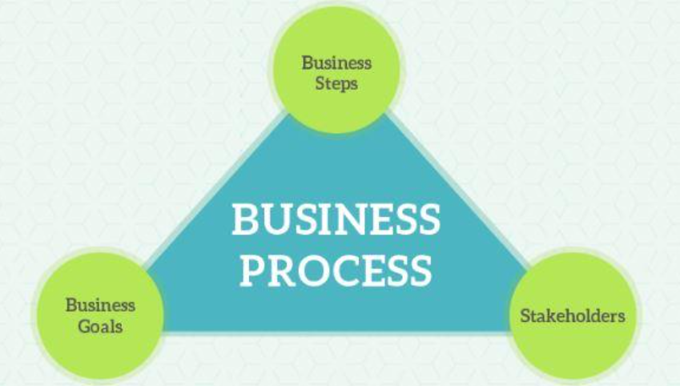

In above pictures we can see three important elements of business process for example business steps, business objectives and Stakeholders. It refers to wide extend of organized and it implemented to achieve a predetermined organizational objective. Business process use in all organizational levels; a few may visible to clients and a few may not.

The required and the advantages of a business process are very clear in large organizations. A process forms the help for any trade and makes a difference it streamline person activities and make beyond any doubt that resources are put to their ideal use. Business process helps to recognize what assignments are important to your bigger business, stream line them to move forward additionally offer assistance to streamline communication between people, functions, offices, to achieve particular tasks. It sets a chain of command of approvals wherever important in order to guarantee responsibility and a greatest utilize of assets, keep chaos from inching into your day to day operations and standardize a set of strategies to total tasks that truly matter to your business

#### Steps of Business Process:

Step 1: Define your goals

In business process first of all we have to know about purpose of business process, why was it created? How will we know if it is successful?

Step 2: Plan and map your process.

In second step we have to know what are the strategies needed to achieve the goals? And need to make broad roadmap for the process.

Step 3:Set actions and assign stakeholders.

To conduct successful business process, we have to identify the individual tasks for teams and machines need to do in order to execute the plan.

Step 4: Test the process.

Testing is the experiment of design process whether it works successfully or not. So, we have to run the process on a small scale to see how it perform. Notice any gaps and make adjustments.

Step 5: Implement the process.

After successful testing of the process, we can implement the process that means start running the process in live environment. Properly communicate and train all stakeholders.

Step 6: Monitor the results.

Monitoring the process is review of the process, analysis of its pattern and documentation of the process history.

Step 7: Repeat

If the conducted process is effective and successful to achieve the goals set, we can replicate it for the future processes.

#### Example of business process

As an example, let’s take the content marketing process. It’s a process you’ll discover in each marketing office out there. The issue is, it can be or maybe hectic and chaotic unless you know the process. There will be writers, creators, SEO specialists, and web designers, all working together to make a single piece of content. Normally, this includes a lot of steps and communication. In spite of the fact that this will vary from organization to organization, the fundamental steps would be as follows.

* The content writer would get the draft and compose the content, whether it’s a web journal article or piece of duplicate. The first draft is written and reviewed to form the final draft, which is at that point passed on to the another person within the workflow.
* The editor surveys the content to guarantee there are no grammatical or copy mistakes within the content. Once this is often done, it moves to the designer.
* The designer takes the content and includes any info graphics or pictures suited to the content.
* After this, the SEO expert reviews the article to guarantee that keywords are all show as they should be, and in case required, make any changes
* Once that’s done, the article is published on the web, with the marketing group promoting visibility.

#### Business processes categories:

On the basis of company, industry, organization and nature of work, business process are categorized into different types and category. Such as:

1. Operational processes

Operational process moreover known as primary forms. It bargains with the center business and esteem chain.Operational process constitutes the center trade of the organization and make the essential esteem stream. Operational processes speak to basic business exercises that fulfill business goals, e.g., creating income. A few examples of this include taking client orders and managing bank accounts.

1. Supporting processes

Supporting handle is secondary process. The processes that support the center processes. Examples include accounting and technical back.

1. Management processes

The processes that oversee the operation of a system. It measures, monitors and control the exercises related to business strategies and systems. Examples of administration processes include inner communications, administration, strategic arranging, budgeting, and infrastructure or capacity management.

### Supporting processes

Support processes are characterized as those within the organization which empower the ideal performance of the center organizational process. Since they support the most processes, they guarantee the business resources within the quality and quantity required, guaranteeing the quality of resources or support administrations and coves the in general effective functioning of the organization. It gives a few fundamental activities and ideas that’s are required to support of all the other categories. Support processes the selection and continuous support off all of the information organized process described in the document

#### Areas of supporting process

Supporting process possess the following process areas.

* Measurement and analysis: Support process recognizes how the practice can measure the viability of how they have actualized information management processes.
* Process management: Support process helps the practice with creating work items, for illustrations approaches, strategy, business glossary, etc
* Process quality assurance: It focuses on making changes in how the information management processes are executed.

### Example of supporting process:

Supporting processes includes following instances:

* Manage finance including costing.
* It manages information system.
* Human resources management.
* IT processes.
* Vendor management processes.
* Risk management processes.
* Security management processes.
* Quality management processes.
* Corporate governance processes.

# Presentation slides

Here I am going to attach my presentation slides which includes and summarize above

Documentation on bullet points highlights.

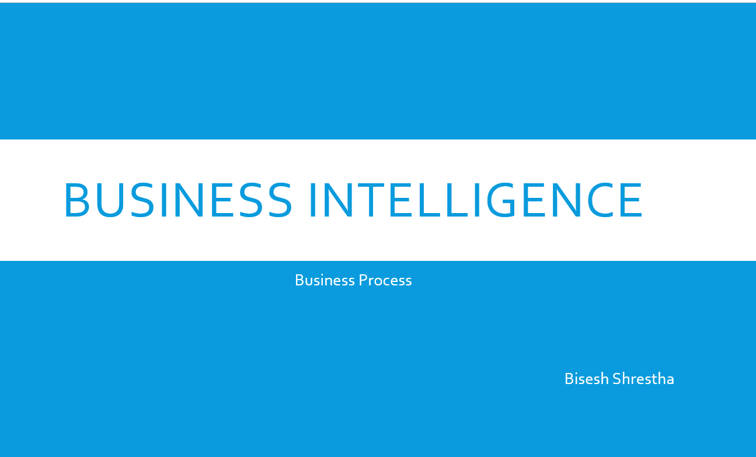

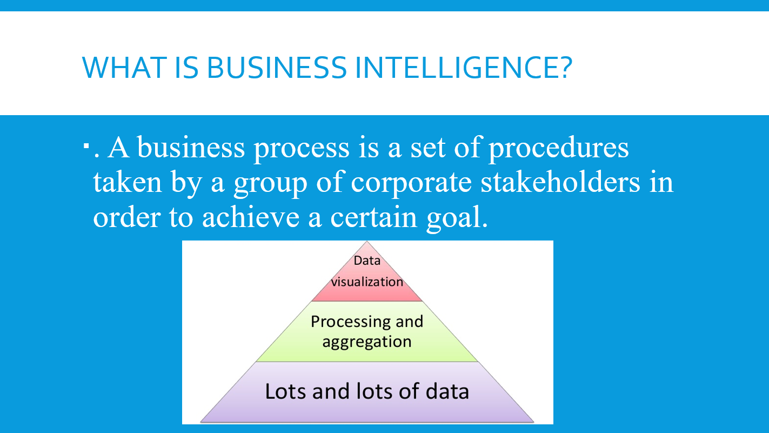

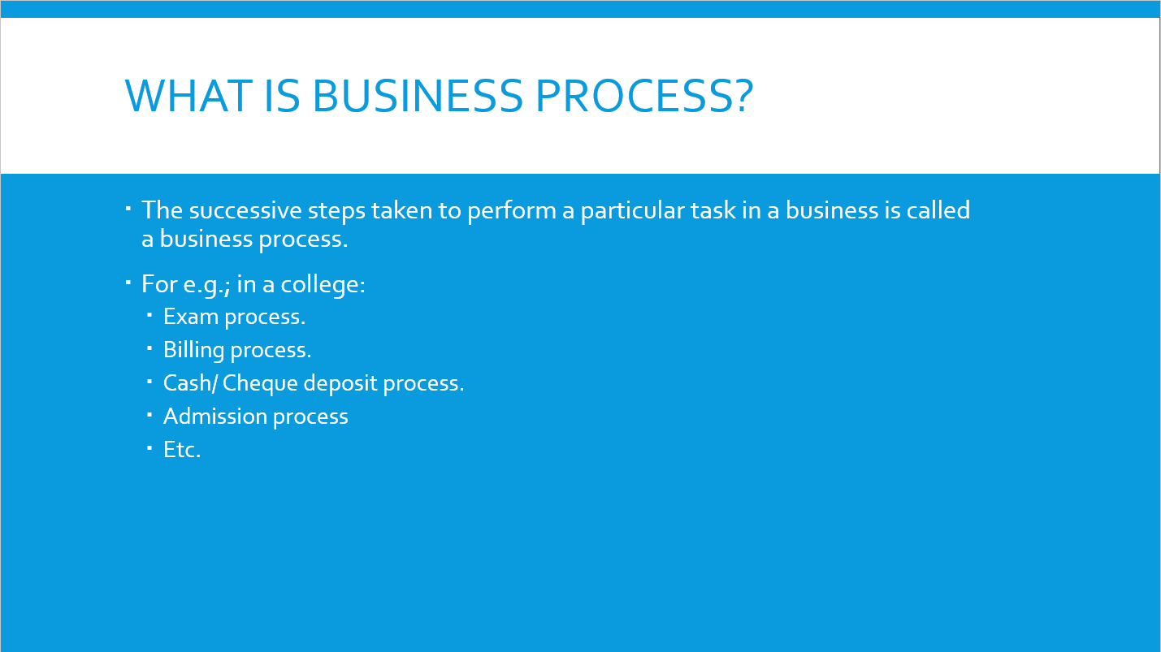

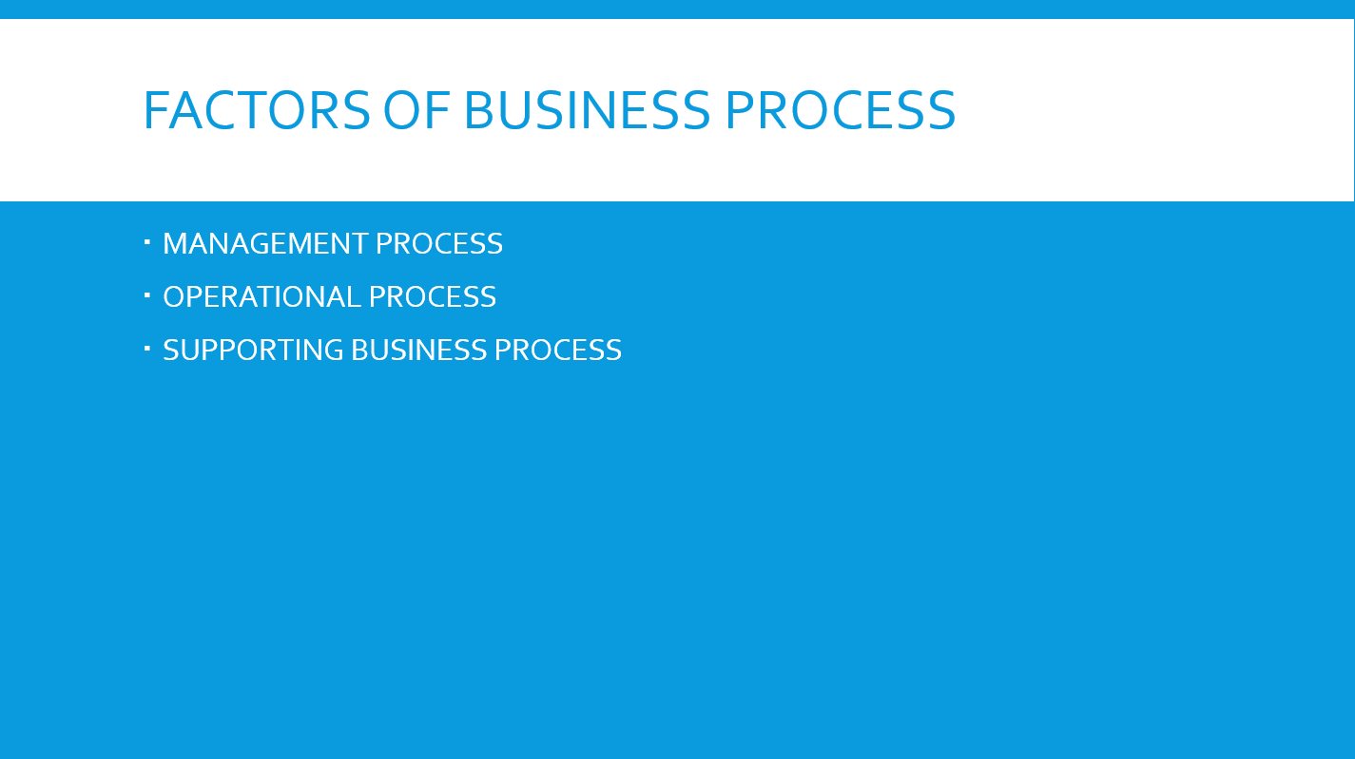

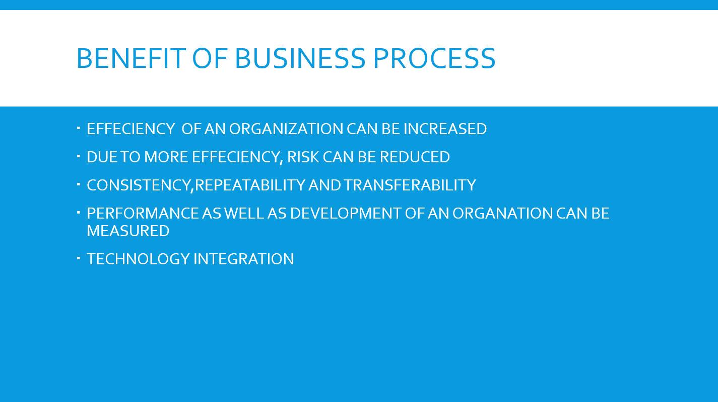

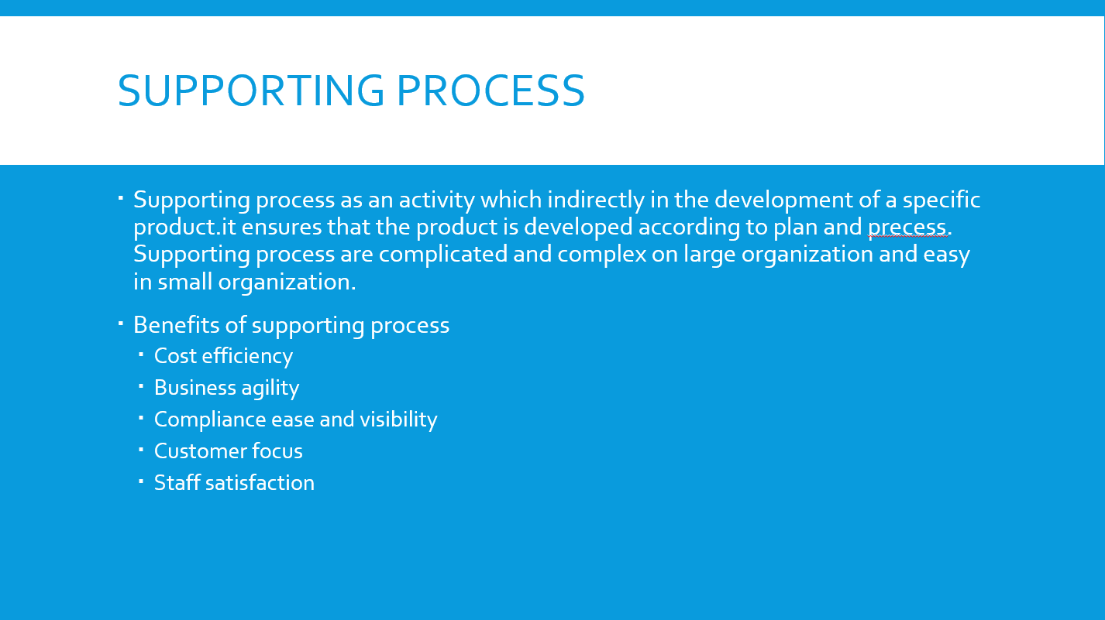

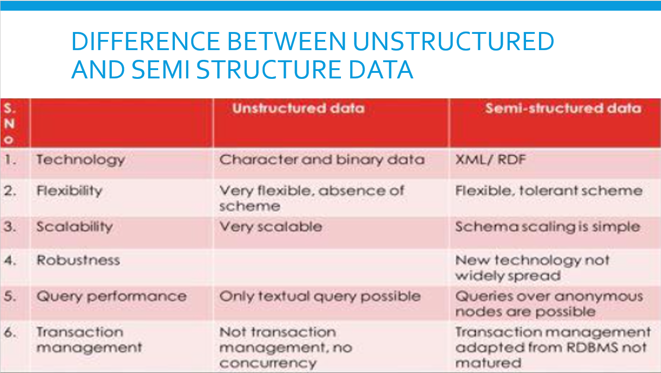

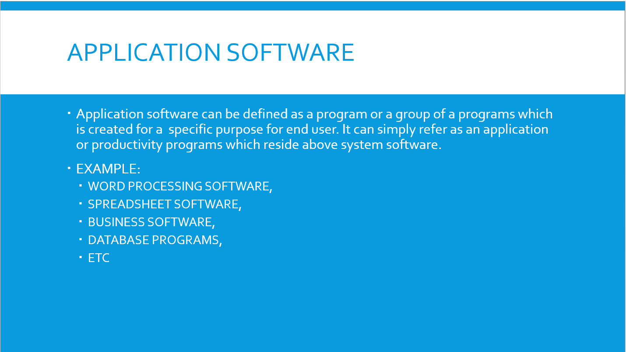

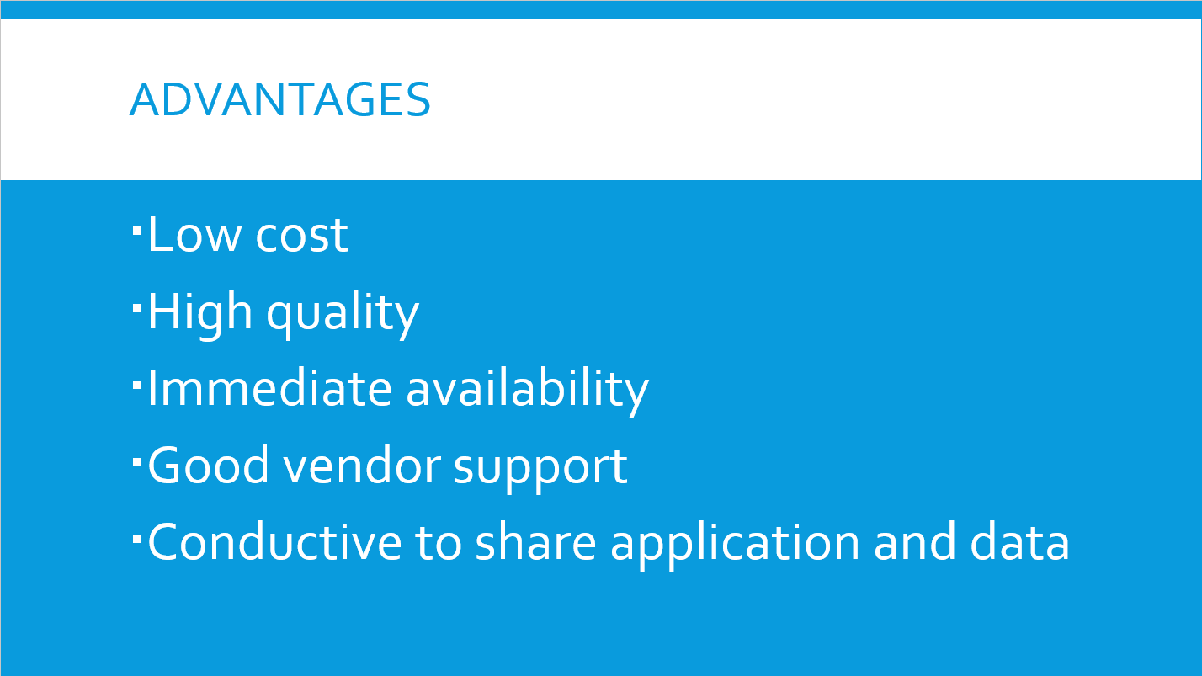

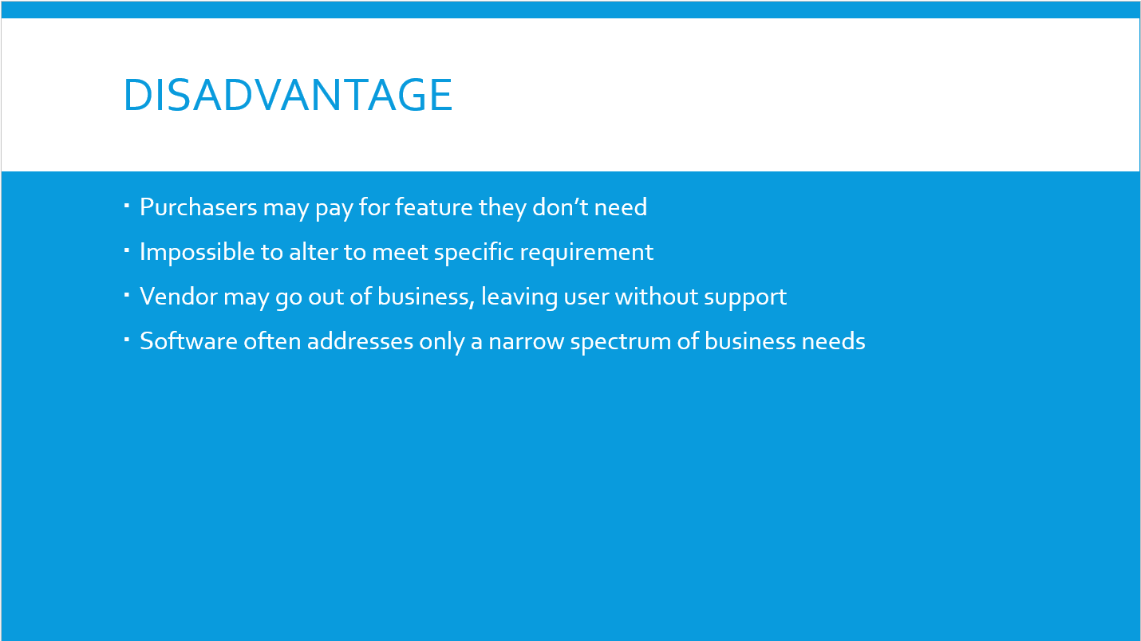

## **Conclusion**

Hence, business process helps to identify what tasks are important to your larger business, stream line them to improve and also help to streamline communication between people, functions, departments, to accomplish specific tasks. It sets a hierarchy of approvals wherever relevant in order to ensure accountability and a maximum use of resources, keep chaos from creeping into your day to day operations and standardize a set of procedures to complete tasks that really matter to your business. So, in this part I have explained about business process, supporting process, different types of data such as structure, unstructured and semi structure and about application software, their advantages and disadvantages while using in business process.

# PART 2:

**Write an article which**

# LO2: Compare the tools and technologies associated with business intelligence functionality

## **INTRODUCTION**

In this part, I am going to get ready an article which compare the distinctive sorts of support available for decision making thoughts at shifting levels inside an organization, justification on the key highlights of BI usefulness additionally getting to compare and differentiate diverse data systems and advances that can be utilized to support organization at operational, strategic and strategic levels.

|  |  |  |  |  |  |  |  |  |  |  |  |  |  |  |  |  |  |  |  |  |  |  |  |  |  |
| --- | --- | --- | --- | --- | --- | --- | --- | --- | --- | --- | --- | --- | --- | --- | --- | --- | --- | --- | --- | --- | --- | --- | --- | --- | --- |
| **The types of support available for business decision- making at changing levels inside an organization**  **Bisesh Shrestha**  **Sunday, November 23,2021**  Business intelligence is a technology-driven handle for analyzing data and showing significant data to assist officials, supervisors and other corporate end users make educated trade decisions. IN today’s energetic world business firms ought to take a number of choices each presently and after that. Directors know how critical decision-making is from the organizational point of see. For case, in inquire about and advancement management has got to. choose whether to seek after one or numerous plan strategies **P2:Compare the types of support available for business decision making at varying levels within an organization.** **Types of support available for business decision making.**  In today’s dynamic world business firms need to take a number of choices each presently and after that. Supervisors know how imperative decision-making is from the organizational point of see. For case, in investigate and advancement administration needs to choose whether to seek after one or numerous plan procedures. Decision making capacity plays imperative role in each sorts of business. So, we got to make adjust choice in our each step of commerce. For that ready to utilize distinctive sorts of support system accessible for business choice making at different level that makes a difference us to create correct decision. A decision support system could be a computerized data system utilized to support decision-making in an organization or a business. A DSS lets clients filter through and analyze massive amounts of information, and compile data that can be utilized to solve issues and make superior choices. Decision support systems permit for more educated decision-making, opportune problem-solving, and moved forward productivity for managing with issues with quickly changing factors.  Following are some decision-making supports available:   * Communication-driven support   It is a type of support system that emphasizes communications, collaboration and shared decision-making bolster. It enables communication between bunches of individuals, encourages the sharing of information, supports collaboration and coordination between individuals and also supports in gather decision tasks.   * Knowledge-driven support   “Knowledge should be shared. It as it were develops by sharing”. Like it’s critical to share information inside the organization, it’s similarly important to decide what to share with whom. Not all details can be shared with everybody. This implies that it is completely essential to choose information sharing rulesand directions, so that it can be utilized viably and suitably. It may be a computer-based thinking system that gives data, comprehension and recommend to clients and support them in choice making.   * Document-driven support   A document driven support makes a difference in document recovery and examination a collection of related, unstructured records looks motors, record ordering and summarization archive and information management.The choice bolster frameworks is able of gathering and showing a few commonplace data such as comparative information figures, getting to data resources that include social and legacy information sources, results of assorted choice options, giving past encounters in a specific setting as well as anticipating figures concurring to suspicions or modern information.   * Data-driven support   It is a type of support that emphasizes access to and control of a time-series of internal company information and now and then outside information. Basic record systems accessed by inquiry and retrieval tools give the foremost basic level of usefulness. Information stockroom frameworks that permit the control of information by computerized devices custom-made to a particular task and setting or by more common devices and administrators give extra usefulness. Data-driven DSS with On-line Analytical Processing (OLAP) gives the highest level of usefulness and choice support that's connected to investigation of huge collections of verifiable information. Executive Data Systems (EIS) and Geographic Information Systems (GIS) are uncommon reason Data-Driven DSS  In above I have talked about different types of support available in business decision making. Now I am planning to talk about this support system totally different changing level with respect to our company “FoodMario”.  **Decision-Making at Different Levels in the Organization:**  Continuous analysis of organizational decision-making handle is basic to high quality and straightforward decisions; something else a commerce runs with a preference: the idea that it is nice at making choice, even if in reality it isn’t. A few choices are related to evaluating investments, distributing resources or surveying mergers and securing proposition whereas a few are almost presenting modern items, considering their rack life or upgrading manufacturing productivity. There are too day-to-day choices that are substantial for a point of time. Regularly, more objective choices are made at lower levels of progression, which can be measured. Higher levels of progression bargain with unstructured or ill-structured decisions, which are subjective in nature. Whereas objective choices may not require creativity, subjective decisions do.    Like decisions made in each department at each level are different, similarly a decision support system examiner must take into thought the type of decisions and recognized variables affecting decision-making some time recently planning to the drawing board and planning the architecture. Above fig gives an indication of the relative number of each sort of decision made at each level within the organizations. In any case, the categories should not be treated as select. For case, the generation supervisor of a apparatus manufacturing firm might primarily be en-gaged in specialized choices, whereas the legitimate adviser of the company may be included in institutional things  From above, we have three different types of decision-making level. They are.  1.Strategic level (top level management)  2.Tactical level (middle level management)  3.Operational level (bottom level management  **Comparative study on different decision making at varying level:**  Given table shows the comparative study on the types of support available for business decision making at varying levels within an organization.   |  |  |  |  | | --- | --- | --- | --- | | S.N. | Strategic level (top level  management) | Tactical level (middle level  management) | operational level (bottom  level management) | | 1 | Long term may be 5-10 years | Short term, may be 1-5 years. | Day to day decision making. | | 2 | Made by senior management. | Made by middle level management. | Mainly made by low level | | 3 | decisions are made according to a company's goals or mission | Based on aims or goals of organization. | are often highly structured, repetitive and routine. | | 4 | More general in nature. | Ensure the structure of information, accountability, resources (people, money, tools and items) are consistent with the objectives of company. |  |  | | 5 | EXAMPLES: What products will business produce, which market sector will we aim for, Increase market share, To have 100% customer satisfaction. | EXAMPLE: Increase number of employee, Re- name business, Promotion of employee. | Example: Arranging work routine, Dealing with customer complaints, Ordering materials from suppliers. |  Summary There are different types of information systems utilized in business organizations. Exchange preparing systems outlined to records the everyday schedule exchanges essential to the conduct of the business. Office computerization systems planned to support office tasks. Process control systems planned to Monitor and control mechanical or physical processes. Management information system (MIS) essentially concerned with changing over information from inside sources into data which is at that point communicated to supervisors at all the levels, in all capacities to form opportune and compelling choices for arranging, coordinating and controlling the exercises for which they are responsible. Decision support systems outlined to assist manager in decision making that needs modeling, detailing, calculating, comparing, selecting the most excellent alternative or anticipate the scenarios. Executive information systems give senior directors with a system to help in taking key and strategic decisions. Expert system program planned to imitate human thinking. This ponder endeavors to clarify the part of each sort of data systems in commerce organizations. |

p.t.o

## **Conclusion:**

Hence, in this portion I have talked about distinctive sorts of support available for decision making, key highlights of business intelligence usefulness and diverse data frameworks and innovation that utilized to support to back organization at operational, strategic and strategic levels.

# Part:3

# LO3 Demonstrate the use of business intelligence tools and technologies

## **P3: Determine, with examples, what business intelligence is and the tools and techniques associated with it.**

## **Introduction**

Being founder as well as Business analyst of Foodmario I should have very good knowledge about the BI to run the business in profitable order. So, on this part of task I am going to produce a report which determine, with examples, what business intelligence is and the tools and techniques associated with it as well as I am going to design a business intelligence tool, application or interface that can perform a specific task to support problem-solving or decision-making at an advanced level also I am going to provide a critical review of the design in terms of how it meets a specific user or business requirement and identifying what customization has been integrated into the design and also, I am going to discuss how business intelligence tools can contribute to effective decision-making, I am also going to explore the legal issues involved in the secure exploitation of business intelligence tools as well as I am going to conduct small survey to identify specific examples of organizations that have used business intelligence tools to enhance or improve their operations and finally I am going to evaluate how organizations could use business intelligence to extend their target audience.

**BUSINESS INTELLIGENCE**



“Demonstrating the uses and implementation of business intelligence tools and technologies”



SUBMITTED BY:

BISESH SHRESTHA

### Executive summary

The main motive of using business intelligence is for quicker and more accurate business reporting, to create better business choice, to supply fulfillment to their client, to extend trade efficiency, etc. BI has a direct affect on organization's strategic, tactical and operational trade choices. In order to run the business in intelligence way it is much more essential to have the concepts approximately the tools and strategies related with BI. Being founder as well as Business investigator of FOODMARIO, I should have very great information about the BI to run the business in beneficial arrange**.** Here, I am going to determine, with examples, what business intelligence is and the tools and techniques associated with it as well as I am going to design a business intelligence tool, application or interface that can perform a specific task to support problem-solving or decision-making at an advanced level also I am going to customize the design to ensure that it is user-friendly and has a functional interface and finally I am going to provide a critical review of the design in terms of how it meets a specific user or business requirement and identifying what customization has been integrated into the design and going to discuss how business intelligence tools can contribute to effective decision-making, I am also going to explore the legal issues involved in the secure exploitation of business intelligence tools as well as I am going to conduct small survey to identify specific examples of organizations that have used business intelligence tools to enhance or improve their operations and finally I am going to evaluate how organizations could use business intelligence to extend their target audience.

**Scope**

➢ Helps in the measurement of performance and progress toward business goals.

➢ Initiates quantitative analysis through predictive analytics, predictive modeling, business process modeling and statistical analysis.

➢ Helps in obtaining goals of the organization.

**Objectives**

➢ To determine the concept what business intelligence is, illustrate the concept with reference to specific examples.

➢ To design a business intelligence tools/apps/program that can perform specific task to support problem solving or decision making for your organization.

➢ To provide a critical review of the design.

➢ To discuss how business intelligence tools can contribute to effective decision-making. ➢ To explore the legal issues involved in the secure exploitation of business intelligence tools. ➢ To Conduct small survey to identify specific examples of organizations that have used business intelligence tools to enhance or improve their operations. ➢ To evaluate how organizations could use business intelligence to extend their target audience.

### Introduction

The term business intelligence begun in 1989; earlier to that numerous of its characteristics were portion of executive data systems. Business intelligence emphasizes analysis of large volumes of information around the firm and its operations. It includes competitive insights (checking competitors) as a subset. In computer-based situations, business intelligence employments a large database, regularly put away in a information distribution center or information shop, as its source of data and as the premise for advanced analysis. Business Insights moreover can be characterized as a advances and techniques utilized for collection and investigation of raw information, at that point changing over it to important data for business activities. The main motive of utilizing business intelligence is for quicker and more accurate business reporting, to form better business choice, to supply fulfillment to their client, to extend business productivity, etc. BI encompasses a direct effect on organization's strategic, strategic and operational business decisions. BI supports fact-based decision making utilizing historical information instead of suspicions and gut feeling. (Guru99.com, 2019)

### Examples of Business intelligence

Example 1:

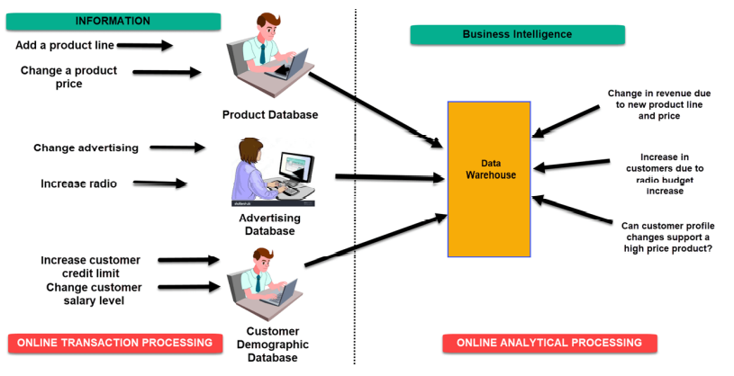

Above figure illustrates what is business intelligence basically. It shows process of collecting data and analysis of data in systematic steps. In an Online Transaction Processing (OLTP) system information that could be fed into product database could be add a product line and change a product price. Correspondingly, in a Business Intelligence system query that would be executed for the product subject area could be did the addition of new product line or change in product price increase revenues.

In an advertising database of OLTP system query that could be executed by Changed in advertisement options and Increase radio budget. In BI system query that could be executed would be how many new clients added due to change in radio budget. In OLTP system dealing with customer demographic data bases data that could be fed would be increased customer credit limit and changed in customer salary level.

Correspondingly in the OLAP system query that could be executed would be can customer profile changes support higher product price.

Example 2:

A bank gives branch managers access to BI applications. It helps branch manager to determine who the most profitable customers are and which customers they should work on. The use of BI tools frees information technology staff from the task of generating analytical reports for the departments. It also gives department personnel access to a richer data source. So, business intelligence is very useful technique in 21st century business modality.

### Tools and techniques associated with Business Intelligence

BI has a direct impact on organization's strategic, tactical and operational business decisions. BI supports fact-based decision making using historical data rather than assumptions and gut feeling. BI tools perform data analysis and create reports, summaries, dashboards, maps, graphs, and charts to provide users with detailed intelligence about the nature of the business. Business intelligence tools can be a great resource to improve your business. With the rise of data in today’s digital age, business intelligence tools have exploded, making data and analytics assessable for more than just analysts. What is business intelligence? Business intelligence technology is a tool used to analyze and present information to help decision makers make more informed and smart business decisions and strategies. Following are some tools and techniques available in BI.

### Predictive Analytics Tool

BI solution majorly helps you to analyze the data and patterns by analyzing your past information sets. But one capability which a BI solution must have is the predicting capabilities, it empowers the decision producers to predict the advertise patterns, and other business requirements like deals, staffing, market trends etc. With the utilize of predictive analytics, it helps an organization to be proactive, forward looking, hold and develop their customer with improving business operation on their business.

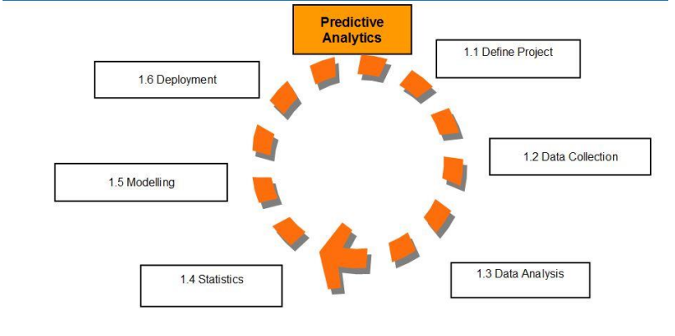

Predictive analytics is reflected in today Big Data Trends, and its tools are basically Big Data Technologies. The market demand for predictive analytics program compares with a closely related toolset, Big Data Analytics Tools. It makes a difference optimizing promoting campaigns, moving forward operations, fraud location and decrease dangers. For illustration, retail is Likely the biggest segment to use prescient analytics, retail is continuously looking to improve its deals position and forge way better relations with customers. One of the foremost ubiquitous cases is Amazon’s proposals. When you make a buy, it puts up a list of other comparative things that other buyers obtained.

Much of this is within the pre-sale area – with things like sales estimating and advertise investigation, customer division, modifications to business models, adjusting IT to business units, managing inventory to account for regularity, and finding best retail areas. But it moreover acts post-sale, acting to diminish returns, get the customer to come back and expand guarantee sales. For case, the budgetary industry might utilize it to calculate investment dangers and see where the advertise can go while marketers use it to try to get it consumers’ buyer’s ventures and where the most optimal area is to set up call to activities. Predictive analytics tools can assist you get it the future by learning from the past.

### Multi-Cloud Strategy

Cloud-based technology has developed significantly in recent years and has significantly affected the business world. Nowadays, numerous companies are moving towards it due to its availability and simple to use attributes. Gartner forecasted that by 2019, cloud-based techniques will ended up the essential strategy for almost 70% of companies. Cloud-based technology offers reduced risk and more flexibility that can permit your teams to collaborate effortlessly. In case you haven’t yet, consider levering a cloud-based strategy this year. So, more businesses will be moving to this technology. As per their predictions inside some of years, the investing on cloud-based analytics will develop 4.5 times faster. (Tec funnel, 2019)

### OLAP (Online Analytical Processing)

OLAP (Online Analytical Processing) is the technology behind numerous Business Intelligence (BI) applications. OLAP could be a effective technology for information discovery, including capabilities for limitless report seeing, complex analytical calculations, and predictive “what if” situation (budget, forecast) planning. OLAP performs multidimensional investigation of trade information and gives the capability for complex calculations, drift investigation, and modern information modeling. It is the foundation for numerous sorts of business applications for Business Performance Management, Planning, Budgeting, Determining, Budgetary Detailing, Examination, Simulation Models, Information Discovery, and Data Warehouse Reporting. OLAP empowers end-users to perform advertisement hoc analysis of data in numerous measurements, in this manner giving the knowledge and understanding they require for better decision making. By utilizing OLAP method a company that can take advantage and turn it into shared information, precisely and rapidly, will doubtlessly be way better positioned to form successful business decisions and rise over the competition. (OLAP.com, 2019)

### Data Mining

Business Intelligence is the ability to convert information into data and data into knowledge. It is perfect way to the most perfect way to optimize the decision-making handle in business. In this sense, Business Intelligence may be a set of strategies, applications and innovations to gather, refine and transform this information from value-based systems and unstructured data (inside and outside to the company), in structured data for direct exploitation or for analysis.

Data mining tools give superior customers relationship management, as well, through mining genuine habits and diverse designs. In continue, Business Intelligence technique should be utilized to apply the knowledge to maximize the benefits of the company. Thus, Business Intelligence acts as a vital figure for a business, giving insider data to react to business issues: entering unused markets, financial control, cost optimization, production arranging, examination of client profiles, benefit. That's how data mining is utilized to produce Business Intelligence.

### Sisense

Sisense is one of the finest BI software which empowers businesses to collate, analyze and view data, which can be utilized in making sound business decisions and to come up with key plans. The tool totals all required data into a particular dashboard with its drag-and-drop functionality and gives you with a granular view of your data. Users can come up with solid analysis using visual reports as a premise, making the method. Distant less demanding and hassle-free. The platform’s interface is simple to utilize, permitting users to memorize system navigation rapidly and effortlessly. Sisense includes different special highlights such as in-chip engine and restrictive technology, single stack design, ideal utilize of computational resources, solidification of charts from different sources and negligible TOC. (Financesonline.com, 2019)

### Tableau

In business intelligence Tableau aids businesses in visualizing and making sense of data. It enables organizations to connect, visualize and share data through PC or iPad. Users can easily create dashboards, publish and even share them with colleagues, partners, and customers without the need for programming knowledge. Apart from that the different types of data sources which tableau support in business filed are MS Excel, My SQL, Salesforces, Oracle, etc. Tableau Desktop (for everyone), Tableau Server (analytics for organizations) and Tableau Online (hosted analytics for organizations) are the three types of product that are offered by Tableau software. Tableau includes several unique features like a pioneer of drag-and-drop analytics, dashboard-to-dashboard interactions, SAML authentication, mobile web authoring, various runtime versions available etc.

### Clear analytics

Clear analytics is one of the useful tools in business fields. This business intelligence tool is an intuitive Excel-based software that can be used by employees with even the most basic knowledge of Excel. What you get is a self-service Business Intelligence system that offers several BI features such as creating, automating, analyzing and visualization your company’s data.

### Microsoft BI platform

Microsoft Business Intelligence platform include Analysis Services, Integration Services, Master Data Services, Reporting Services, and several client applications used for creating or working with analytical data. This section of the SQL Server Setup documentation explains how to install these features. Analysis Services and Reporting Services can be installed as standalone servers, in scale-out configurations, or as shared service applications in a SharePoint farm. Installing the services in a farm enables BI features that are only available in SharePoint, including Power Pivot for SharePoint and Power View, the Reporting Services ad hoc interactive report designer that runs on Power Pivot or Analysis Services tabular model databases. (NT, 2019)

## **P4. Design a business intelligence tool, application or interface that can perform a specific task to support problem- solving or decision-making at an advanced level.**

Business intelligence is known for its intelligence in analyzing, solving and understanding the problem in a business and takes the business to higher level. Tools such as Scene, Looker, Small scale strategy, etc. are utilized in business recorded and as per the requirement of the assignment I have planned an interface, so that I can perform issue solving task or decision-making at a progress level.

### Dashboard

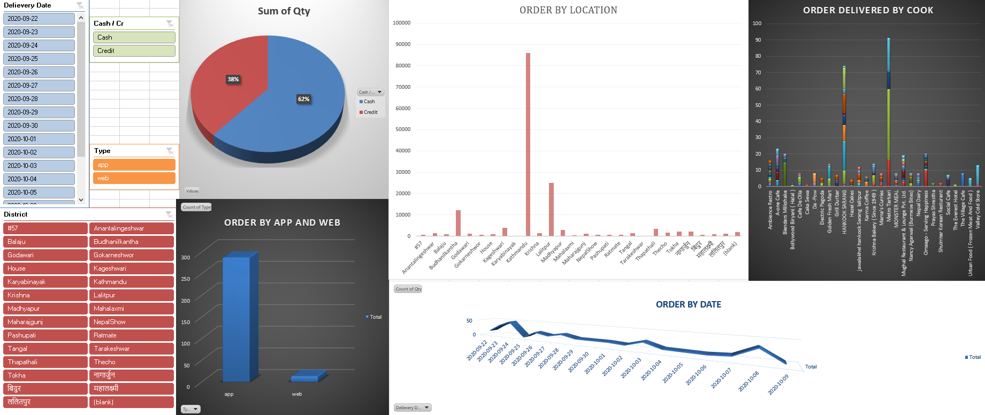

With the use of MS-excel, I have made an interface based on scenario which is for the data analysis of food Mario. In this interface I have utilized diverse sorts of button to form menu, to represent them as Line Chart, Histogram, Pie Chart, Bar Chart and each of these buttons are connected with data, on clicking on these button we will get result as per we have chosen.

### Different Charts

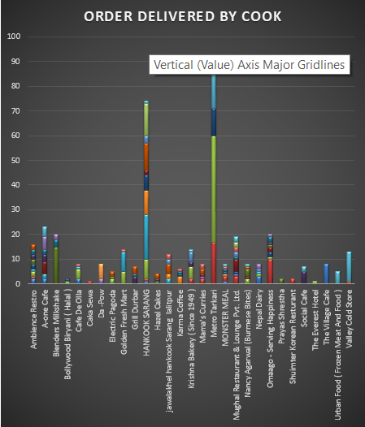

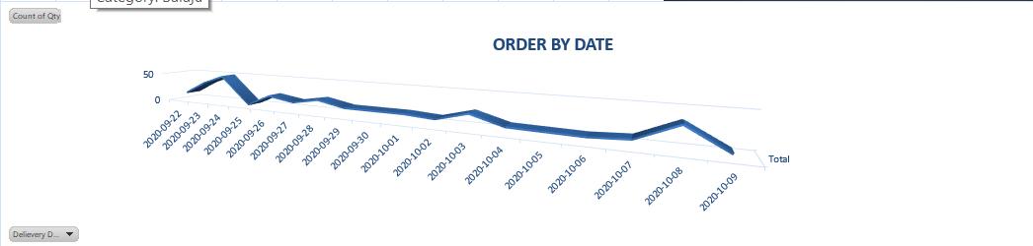

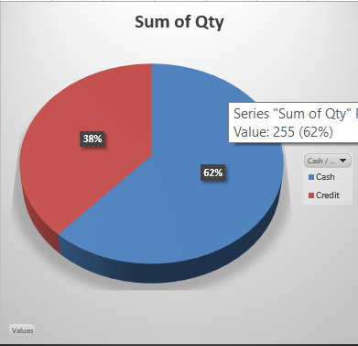

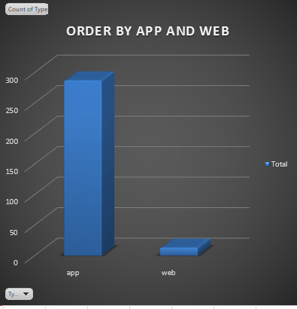

### Slicer tools

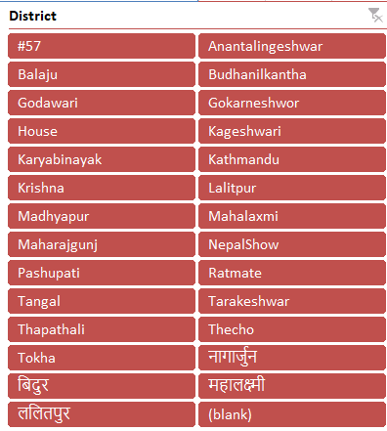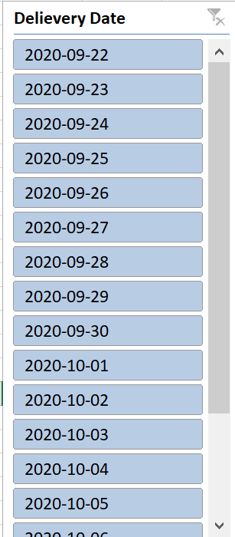

In above I have presented the Screenshots of business intelligence tool, application or interface that can perform a particular task to support problem-solving or decision-making at an progressed level. In arrange to create these tools, I have utilized excel. Utilizing the designer work accessible in excel I have planned this application. With the help of this application one can effortlessly make the decision according to his/her require and can elevate their business status. This application is much more user friendly. It is simple to do. And the output from this tool will be hundred percent successful. With the use of these tools it'll be simple for company to examination and visualize their data and information can be overseen appropriately. Apart from that they can make effective plan with appropriate choice making so that development of business can be done effectively.

Hence, the decision-making software helps for the betterment of the organization, with the help of this software any task can be performed easily and the organization can move toward the path of success.

# PART 4

# LO4. Discuss the impact of business intelligence tools and technologies for effective decision-making purposes and the legal / regulatory context in which they are used

## **P5.Discuss how business intelligence tools can contribute to effective decision-making.**

Business Intelligence can be defined as a technologies and strategies used for collection and analysis of raw data, then converting it to meaningful information for business actions. The main purpose of business intelligence is to support better decision making in business. Business intelligence can provide a company with rich data resources that can help it achieve its business goals and targets by guiding timely strategic decisions. Interactions with customers through phone calls, email, online chat, etc; can be thoroughly analyzed by business intelligence gathering teams with the aim of getting vital insights that can be efficiently leveraged to provide immense value of the business in the long term. Being in business ultimately means being in the business of decision making. Decisions play vital role in any kind of business, right decision made at right time and implemented in the right manner make all differences. This surely has become difficult. Things change very quickly, we are far more connected, and we need to act fast while grappling with far more complexity. There always seem to be too many things to keep tab on, and too few ways to make sense of it all. Studies show that the highest performing businesses leverage data effectively for decision making. (Advaiya, 2019)

Let’s talk on the basis of particular scenario, as for the marketing department, it helps them grow the top line. It helps them analyze the results of their campaign and promotional yields. And it helps them fine-tune their spending to get better ROI. In the sales department, business intelligence helps them find the best path and best practices, the cost and length of customer acquisition, process improvement, and year-by-year analysis of turnover and sales. Business intelligence helps the human resource department track and manage things like employee turnover, attrition rate, recruitment process, and so on. Aside these, every other department within a company will benefit directly or indirectly from business intelligence. Correct usage of this strategy has shown excellent results across all sectors; be it e-commerce, media, non-profit organizations, healthcare, telecommunication, financial services, energy, and so on. Business intelligence helps in decision making due to the multiple powerful elements it entails. These include interactivity, data visualization, database connection, mobile business intelligence, predictive analytics, application integration, and ad hoc reporting. Now, let’s take a closer look at each of these elements.

### Decision-making tools use in business intelligence.

Some of the effective decision that Business Intelligence tools helps to make are:

1. **Interactivity**

There should be a high level of interactivity between the dashboard and the difference report. For example, if a person is seeing and analyzing the total sales report, some interaction should be involved. This will help the person dig further into the report to figure out region wise sales, product wise sales, time period wise sales, and so on. The more the level of interaction, the more the volume of vital information that will be retrieved; and the better the decisions that will be made.

1. **Data visualization**

Having data visualized in a correct format is very important, as this facilitates better understanding of the data. For example, month-on-month sales could be represented in the form of a line graph rather than just words or verbal communication. Similarly, a component wise contribution could be best represented with a pie chart. Only when data is represented in the correct format can any useful insight be extracted from it.

1. **Connection to databases**

During a business intelligence procedure, the analysts in charge should be able to fetch information by connecting to different databases and web services, so that they will get access to the right information irrespective of its source. With the right information, helpful recommendations can be made that will help a company grow.

1. **Predictive analytics**

With the aid of historical data and high-end algorithms, certain predictions can be made, such as the likelihood of customers coming back for repeat business, expected revenue, expected region wise sales, machine failure, and so on. This can help a company to be proactive.

1. **Application integration**

A business intelligence tool should be easily integrated with your existing application or software regardless of whether it is developed in Java, C, Ruby, PHP, or any other platform.

1. **Mobile business intelligence**

With more and more workforce going mobile and handling tasks on the move, they need to have the right information on their mobile devices, such as smartphones and tablets. So, all reports dashboards and graphs should be compatible with mobile devices. (Profitableventure.com, 2019) This is not limited to just a few roles in the organization. At all levels, people need to make decisions be accountable and confident. And if organizations can enable its employees with right tools chances are that they will get it right. Informed decision making relies on current and comprehensive information. Relevant information often resides in a multitude of sources—a plethora of databases, documents, and spreadsheets, social networks, or web. Access to data models which bring together these sources in a meaningful manner allow decision makers to be equipped with timely information and be not blindsided. There can be too much information, though. Only through right visualization and summarization, we can understand and analyze it well generating insights as we draw conclusions. This happens when we are able to visualize information as relevant to the business model. Insightful tools can identify patterns, allow us to analyze scenarios, and plan better. These insights influence decisions in a powerful manner. Hence, Powerful decision making is about being able to be confident and accountable. Decisiveness that works comes from being informed, insightful and impactful. The confidence that arises from comprehensive information, deep understanding and ability to implement, leads to results.

## **P6.Explore the legal issues involved in the secure exploitation of business intelligence tools.**

The business intelligence tools that are utilized for the effective decision making for a business can have a few lawful issues as well. As everything is computerized, the tools utilized are too a few sort of software. So, the computer program that are utilized ought to be utilized the authorized individual so that one can make the utilize of the analyzed data. As these things are basic and are gathered to be kept secure. The privacy and security is additionally a legal issue. The protection of the data should be kept up and the security should be incredible sufficient to ensure the data. For this different tools and strategies are available. The tools are gathered to be utilized correctly and for the good thing about the business and not for individual use.

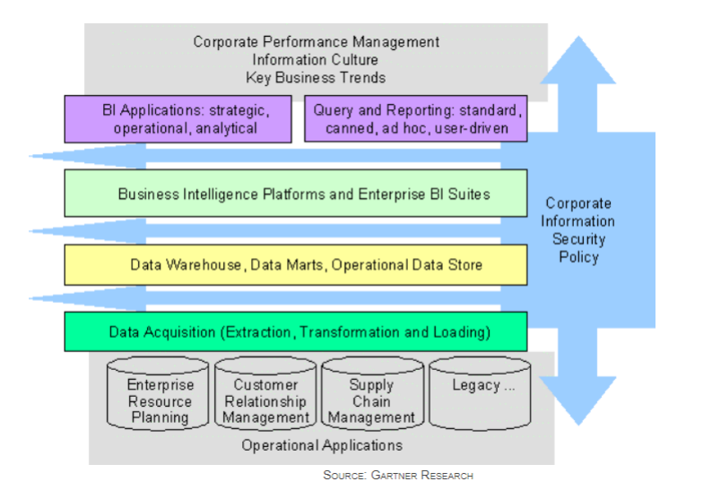

### Cyber security management:

(Forbes.com. 2019) Cybersecurity management can be described as everything an organization does to protect its information systems and computer networks from cyber-attacks, intrusions, malware and various types of data breaches. All businesses and government agencies are vulnerable to cyber-attacks that are growing in sophistication, as well as in number. Keeping networks running smoothly and protecting sensitive data takes constant monitoring and proper cybersecurity management. Business intelligence strategy has ushered in a new era for organizations the world over. A strong focus on data analysis has business leaders enjoying reduced costs, increased efficiency, and allaround better decision-making. When previously unheard-of ROI is touted in headlines regularly, it sparks more businesses to follow suit and jump on the BI movement. However, many do so without considering the full implications of business intelligence on data security. Basically, the BI tools are used for the organizational, personal and legal/regulatory context to store the valuable data. For the organization like our IT company, we use the BI tools to store the data that we have obtain from the research and to analyze the data that we have stored. By doing this we can give competition to the many organization like ours. In one line it can be said that in most of the context BI tools are used to store and to protect the data.

### Discovering BI Security Risk:

The mere act of producing, receiving, or housing data always poses a danger if left unsecured. Those incorporating BI strategy into their operations are at least more aware of their data, of what it is and where it is housed. But knowledge doesn’t equate to security. The insights drawn from BI and data analysis are no longer unstructured 1s and 0s, but highly-sensitive easily understandable information, making it even more valuable to a hacker. If they can steal data that has already been analyzed, then they are in effect stealing the very keys to your success. Liken it to a car thief. Instead of just robbing a garage for a few spare parts, they’re boosting Ferraris right off the dealership lot.

## **Methods to protect the Risk:**

In every context there are different kinds of risk related to the BI and BI tools. The best methods to protect those risk for the organizational, personal and legal/regulatory context are as:

#### Encrypting and Segmenting Data Insights:

Given that BI insights are of extreme value to hackers, it’s especially important to secure data once it’s unraveled. Many base-level essential security practices must be adapted to business intelligence. Before insights are stored or sent to someone else, they must be encrypted. At the very least, this practice will drastically slow down a hacker from making sense of our private data. Today, it’s possible to encrypt massive amounts of information quickly, proven by the IBM Z machine which can process 12 billion encrypted transactions per day. Neglecting encryption is a mistake, and one that may have contributed to the enormous Equifax breach. Additionally, thinking strategically about segmenting both our network and data storage. Siloed raw data is inefficient for analysis, but siloed data insights can be a safe practice. This way, should a hacker gain access to one section of our network, they won’t have automatic access to every insight we have. It’s the difference between mining for gold nuggets and strolling into a vault at Fort Knox.

#### Determining Access and Permissions:

BI insights are powerful, and power in the hands of the wrong user can be dangerous. While we may trust all our employees, it’s not safe to give them all unlimited access to these insights. While employees should certainly see data results and trends that are applicable to their jobs, many of these items can be distributed to them from a supervisor or management. At the inception of a BI strategy, it’s necessary to scrutinize every employee’s role to determine the necessity of their access to BI tools and data. Even if we’re certain a disgruntled worker won’t try to wreak havoc and corrupt our data, if they don’t truly need access to certain BI tools then they may neglect basic security measures (like updating their password) and serve as an unknowing invitation to a hacker.

#### Applying BI to Data Security:

Many business leaders understand that data can be used to learn significant insights about their companies, but the fact BI can be used to address security is often neglected. Data analysis can discover backdoors, network inconsistencies, or technological issues that hackers can take advantage of. With real time results, BI security strategy can monitor data as it enters or leaves your organization to discover any questionable activities immediately.

#### Policy Enforcement:

In order to ensure the integrity of data, stakeholders should consider appointing a corporate czar to oversee data input. Low-quality data on the front end is not congruent with actionable BI.

#### Leadership Competencies Leadership:

Competencies can be defined as a skills and behavior which helps in better performance in work. By using different types of business Intelligence tools in an organization, a person can make better business decision by analyzing current situation as well as increase leadership skills with which it helps better productivity of goods. Apart from that by choosing skilled leadership with the help of Business Intelligence tools an organization can set vision and strategy with which they can make better policies and risk in an organization can be solved with an ease. Also, if any types of modification, changes and monitoring of devices in an organization can be done without any types of problem.

#### Training and Support:

(Forbes.com. 2019) A strong BI platform will likely produce data sets that are far larger than those clients are used to examining. Law departments should expect their solution providers to help identify and develop analytics that are process-specific. This requires a thorough knowledge of the industry in order to put process into context. When it comes to understanding process-driven data, certain industries—and law is not one of them—are much better than others. Consider the world of finance, where financial institutions stay in business precisely because of data accuracy. Think of customer deposits, portfolio summaries, and earning reports, for example. Or public companies whose financial statements have to meet accounting standards in highly regulated industries. A solution provider familiar with the legal industry should also make sure not only that law departments get the information they are looking for, but also that they know what they want to accomplish with that information. The two are hardly the same, and solution providers play an important role as teachers and long-term strategic partners in this regard.

## **Conclusion**

Business intelligence doesn’t have to be terrifying there are a variety of resources to teach and empower costumers. There are bounty of sorts of different BI instruments out there to explore and try with. The more educated the customer base becomes, the more comprehensive and effective the choices will ended up. BI could be a flexible and capable resource, and can be valuable to nearly each industry. In this report I have discussed and decided, what business intelligence is and the tools and techniques related with it including the cases, as well as I had planned a business intelligence tool, application or interface that can perform a particular task to support problem solving or decision-making at an progressed level too I had customized the plan to guarantee that it is user-friendly and contains a useful interfacing.

References

SearchCIO. (2019). What is business process? - Definition from WhatIs.com. [online] Available at: <https://searchcio.techtarget.com/definition/business-process>.

Healthit.gov. (2019). [online] Available at: https://www.healthit.gov/playbook/ambulatoryguide/supporting-processes/.

ManagementMania.com. (2019). Support Processes. [online] Available at: <https://managementmania.com/en/support-processes>.

SearchBusinessAnalytics. (2019). What is unstructured data? - Definition from WhatIs.com. [online] Available at: <https://searchbusinessanalytics.techtarget.com/definition/unstructured-data>.

Techopedia.com. (2019). What is Semi-Structured Data? - Definition from Techopedia. [online] Available at: <https://www.techopedia.com/definition/28802/semi-structured-data>.

Famuyide, S. and Famuyide, S. (2019). 10 Benefits of Business Process Management. [online] Business Analyst Learnings. Available at: <https://businessanalystlearnings.com/blog/2014/8/4/benefits-of-business-process-management>.

Anon, (2019). [online] Available at: https://www.quora.com/What-are-the-advantages-anddisadvantages-of-systems-and-applications-software/answer/John-Baker-473.

Managementstudyguide.com. (2019). Analyzing Business Decision Making Process. [online] Available at: https://www.managementstudyguide.com/analyzing-business-decision-makingprocess.htm.

Examples, P. (n.d.). Predictive Analytics: Seven Key Examples | erpinnews. [online] erpinnews. Available at: <https://erpinnews.com/predictive-analytics-seven-key-examples>.

SearchBusinessAnalytics. (2019). What is data visualization? - Definition from WhatIs.com. [online] Available at: <https://searchbusinessanalytics.techtarget.com/definition/data-visualization>.

Features and Conrad, A. (2019). Business Intelligence Features: Important Key Features of BI Software. [online] Selecthub.com. Available at: https://selecthub.com/businessintelligence/critical-business-intelligence-features/.

(2019). What Types of Information Systems Do Organizations Use? [Online] Ecomputernotes.com. Available at: http://ecomputernotes.com/mis/information-and-systemconcepts/typesofinformationorganizationsuse.

Paginas.fe.up.pt. (2019). :::---MANAGEMENT INFORMATION SYSTEMS---:::Chapter 2. [online] Available at: <https://paginas.fe.up.pt/~acbrito/laudon/ch2/chpt2-1main.htm>.

UKEssays.com. (2019). Strategic Operational And Tactical Level Information Technology Essay. [online] Available at: https://www.ukessays.com/essays/information-technology/strategicoperational-and-tactical-level-information-technology-essay.php.

Guru99.com. (2019). What is Business Intelligence? Definition & Example. [online] Available at: <https://www.guru99.com/business-intelligence-definition-example.html>.